**Test Case** **0050**

**System:** VirtuCardsHost and VirtuCardClient

**Description:** Test whether card sleeve changes on Client

**Severity:** 2

**Instructions**

**Test 1**

1. Start VirtuCardClient application
2. Click the button labeled “Sign In”
3. Enter “virtucards01@gmail.com” into the text input labeled “Enter email…”
4. Enter “Testing1” into the text input labeled “Enter password…”
5. Press the button labeled “Login”
6. A window should appear saying “Login Success”
7. Press the OK button that appears on that window
8. Start VirtuCardHost application
9. Repeat steps 2-7 but on the VirtuCardHost application, but use “virtucards02@gmail.com” as the email and use “Testing1” as the password
10. Select the “GoFish” option from the game choices dropdown
11. The checkbox “Allow host to Join” should be checked on the host
12. Press the Create Game button
13. On the VirtuCardClient application enter the 6-character room code found on the host’s screen into the field labeled “Enter Code…”
14. Press the Join Game button on the client
15. Start another VirtuCardClient application
16. Repeat steps 2-7 on the new VirtuCardClient application, but use “virtucards02@gmail.com” as the email and use “Testing1” as the password
17. After both players have joined, press the start game button on the VirtuCardHost application.
18. On the client, press the Settings Button
19. Then press the Change Card Back button
20. Select a sleeve of your choice from your device.

**Expected Result:** The sleeve of all cards on the Client change to chosen sleeve

**VirtuCard Client:**

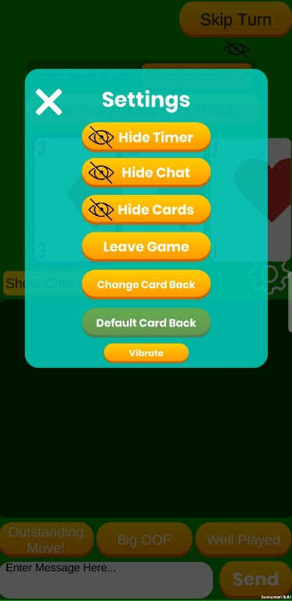

Sleeve Changed:

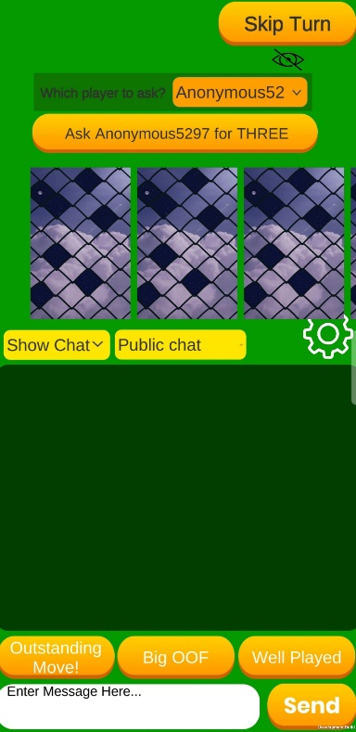

**Test 2**

1. Start VirtuCardClient application
2. Click the button labeled “Sign In”
3. Enter “virtucards01@gmail.com” into the text input labeled “Enter email…”
4. Enter “Testing1” into the text input labeled “Enter password…”
5. Press the button labeled “Login”
6. A window should appear saying “Login Success”
7. Press the OK button that appears on that window
8. Start VirtuCardHost application
9. Repeat steps 2-7 but on the VirtuCardHost application, but use “virtucards02@gmail.com” as the email and use “Testing1” as the password
10. Select the “GoFish” option from the game choices dropdown
11. The checkbox “Allow host to Join” should be checked on the host
12. Press the Create Game button
13. On the VirtuCardClient application enter the 6-character room code found on the host’s screen into the field labeled “Enter Code…”
14. Press the Join Game button on the client
15. Start another VirtuCardClient application
16. Repeat steps 2-7 on the new VirtuCardClient application, but use “virtucards02@gmail.com” as the email and use “Testing1” as the password
17. After both players have joined, press the start game button on the VirtuCardHost application.
18. On the client, press the Settings Button
19. Then press the Change Card Back button
20. Select a sleeve of your choice from your device.
21. Then press the Default Card Back button

**Expected Result:** The sleeve of all cards on the Client change to the default sleeve

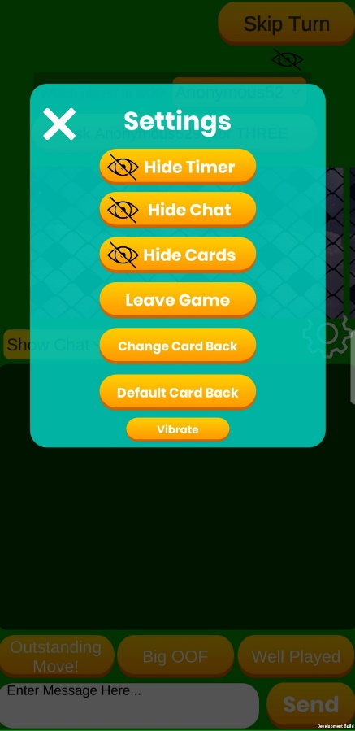

Default Sleeve:

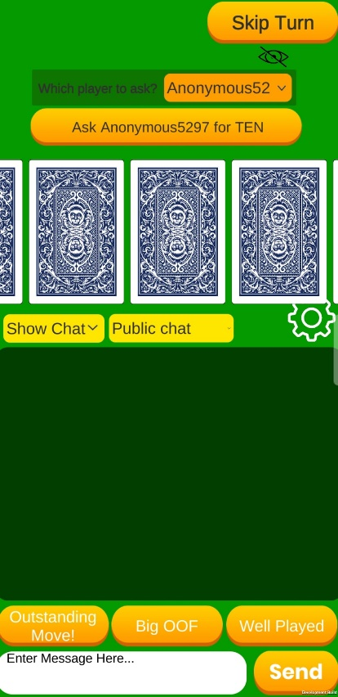

**Test 3**

1. Start VirtuCardClient application
2. Click the button labeled “Sign In”
3. Enter “virtucards01@gmail.com” into the text input labeled “Enter email…”
4. Enter “Testing1” into the text input labeled “Enter password…”
5. Press the button labeled “Login”
6. A window should appear saying “Login Success”
7. Press the OK button that appears on that window
8. Start VirtuCardHost application
9. Repeat steps 2-7 but on the VirtuCardHost application, but use “virtucards02@gmail.com” as the email and use “Testing1” as the password
10. Select the “GoFish” option from the game choices dropdown
11. The checkbox “Allow host to Join” should be checked on the host
12. Press the Create Game button
13. On the VirtuCardClient application enter the 6-character room code found on the host’s screen into the field labeled “Enter Code…”
14. Press the Join Game button on the client
15. Start another VirtuCardClient application
16. Repeat steps 2-7 on the new VirtuCardClient application, but use “virtucards02@gmail.com” as the email and use “Testing1” as the password
17. After both players have joined, press the start game button on the VirtuCardHost application.
18. On the host, press the Settings Button
19. Then press the Change Card Back button
20. Select a sleeve of your choice from your device.

**Expected Result:** The sleeve of all cards on the Client and Host change to the custom sleeve

Changing Card Back on Host

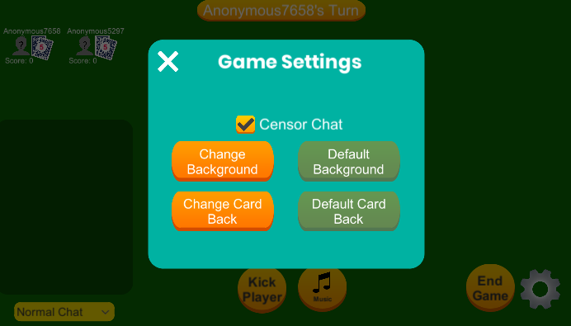

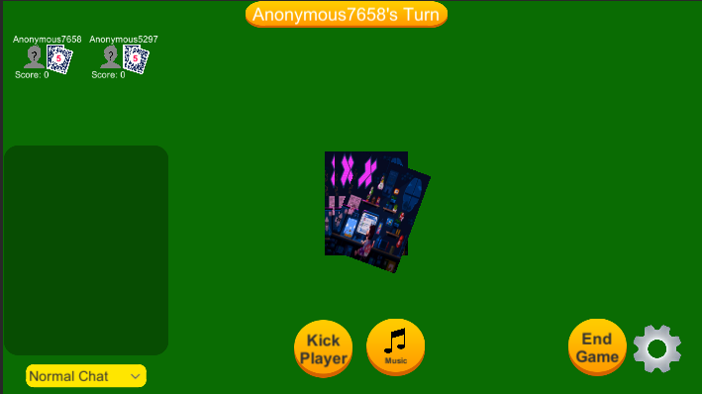

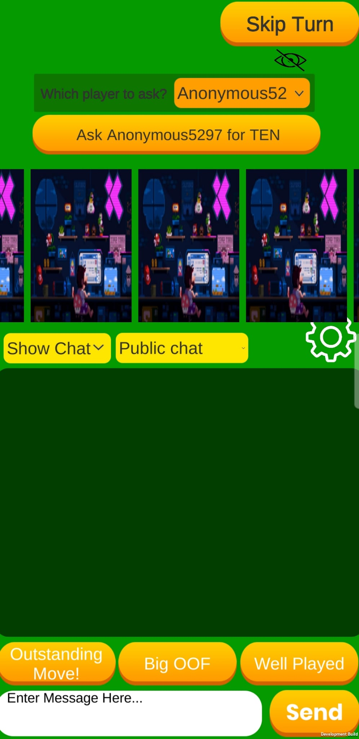

Sleeve Changed on the client

**Test 4**

1. Start VirtuCardClient application
2. Click the button labeled “Sign In”
3. Enter “virtucards01@gmail.com” into the text input labeled “Enter email…”
4. Enter “Testing1” into the text input labeled “Enter password…”
5. Press the button labeled “Login”
6. A window should appear saying “Login Success”
7. Press the OK button that appears on that window
8. Start VirtuCardHost application
9. Repeat steps 2-7 but on the VirtuCardHost application, but use “virtucards02@gmail.com” as the email and use “Testing1” as the password
10. Select the “GoFish” option from the game choices dropdown
11. The checkbox “Allow host to Join” should be checked on the host
12. Press the Create Game button
13. On the VirtuCardClient application enter the 6-character room code found on the host’s screen into the field labeled “Enter Code…”
14. Press the Join Game button on the client
15. Start another VirtuCardClient application
16. Repeat steps 2-7 on the new VirtuCardClient application, but use “virtucards02@gmail.com” as the email and use “Testing1” as the password
17. After both players have joined, press the start game button on the VirtuCardHost application.
18. On the host, press the Settings Button
19. Then press the Change Card Back button
20. Select a sleeve of your choice from your device.

**Expected Result:** The sleeve of all cards on the Host change to the default sleeve

